* Up to the 1950s, conditions such as heart attacks, stroke, cancer, and diabetes were bundled together as degenerative disorders, implying that they might be the natural result of wear and tear and the inevitable consequence of aging.
* To date, the World Health Organization (WHO) has declared only 2 diseases officially eradicated: smallpox caused by variola virus (VARV) and rinderpest caused by the rinderpest virus (RPV).
* 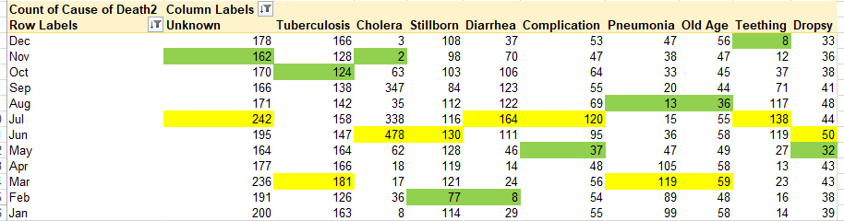
* Until the 19th century, curative medical technology had little effect on the health of society, but after that Vaccine Antibiotic Medication higher standards of living, improved nutrition, better hygiene, and Technology are the improvements over the centuries resulted from control of communicable diseases.
* The control of communicable disease has been the major advance of the 20th century in scientific medicine. It reflects the combination of improved environmental conditions and public health together with the development of immunization, antimicrobial chemotherapy, and the increasing ability to identify new pathogenic organisms.
* As the human civilization advanced the top cause of deaths have changed, what strike me the most was SUCIDE. 1860 & 1898 two male were dead by sucide.